**Article Title**

**Abstract**

Your Abstract must be no longer than 200 words. Please note that since this journal is double-anonymised, your main document must not contain any information that could identify the authors. Such information must be contained in the separate title page.

**Keywords:** At least one keyword must be provided, preferably 3-5. Ideally, these should not repeat words from the title of the paper.

1. **Introduction**

Manuscripts should not exceed roughly 40 double-spaced pages written in 12-point font, including references, Tables, Figures, and not including appendices. Longer manuscripts will be sent back to the authors with a request to revise.

Please ensure the margins are 2.5 cm on each side. This is particularly important for the bottom margin, as ScholarOne will add a footnote to the PDF created for reviewers; if your bottom margin is too small, this will overlap your text and make it difficult to read.

The writing format of the manuscripts submitted to Psychometrika should follow the Publication Manual of the American Psychological Association (APA), 7th ed., 2020.

First-order headings should be numbered 1, 2, 3, etc. A blank line should be left before each section / sub-section heading.

1. **Section headings should be numbered consecutively**
   1. *Second-order headings*

Second-order headings should be numbered 1.1, 1.2, 2.1, 2.2, etc.

* + 1. *Third-order headings*

Third-order headings should be numbered 1.1.1, 1.1.2, 2.1.1, 2.1.2, etc.

* 1. *Tables, Figures, Equations and References*

Tables and Figures must be placed at appropriate locations within the text, not at the end of the paper, for example:

**Table 1.** Example of a Table correctly placed within the text.

|  |  |  |  |  |
| --- | --- | --- | --- | --- |
| Column 1 heading | Column 2 heading | | Column 3 heading | Column 4 heading |
| Sub-heading1 | Sub-heading 2 |  |  |
| Row 1 | Data | Data | Data | Data |
| Row 2 | Data | Data | Data | Data |
| Row 3 | Data | Data | Data | Data |

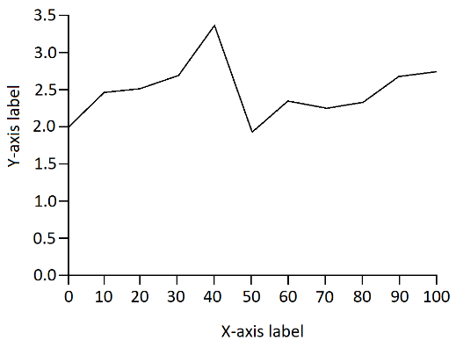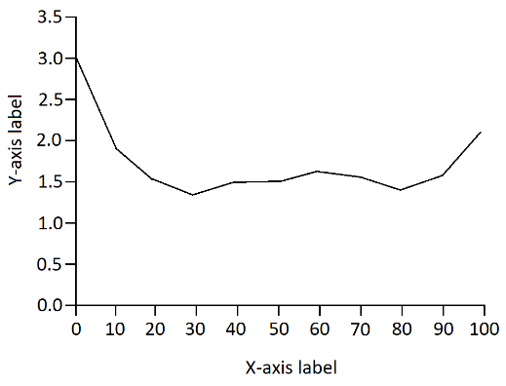

a)

b)

**Figure 1.** Example of a Figure correctly placed within the text.

Please number all Tables and Figures manually rather than using cross-referencing, as these often do not appear correctly in the PDF created by ScholarOne for reviewers.

Equations within the text must be numbered consecutively. If using Microsoft Equation Editor, please ensure that you use a recent version, as conversion to PDF in ScholarOne does not work properly for older versions. If you find this to be the case for your own paper, converting the paper to PDF before uploading it usually solves this problem.

It is vital that you check the PDF proof created by ScholarOne in the last step of the submission process carefully to make sure that all the material to be reviewed is present and appears correctly, with no overlapping footnotes, and nothing that could identify the authors. Only then should you submit your paper.

For references, *Psychometrika* uses APA Author-Date citation style: citations in the text would therefore be written as, for instance: “… Tucker *et al*. (1969) …” or as “… (Tucker *et al*., 1969)”. Note that “*et al.*” is only used in the text, and only where there are three or more authors. For further information on the APA citation style, please consult <https://apastyle.apa.org/style-grammar-guidelines/references/examples>.

The Reference list must be arranged alphabetically by surname of the first author. For more detailed instructions and additional examples, please see the Journal’s Author Instructions:

<https://www.cambridge.org/core/journals/psychometrika/information/author-instructions/preparing-your-materials>

1. **References**

Tucker, L. R., Koopman, R. F., & Linn, R. L. (1969). Evaluation of factor analytic research procedures by means of simulated correlation matrices. *Psychometrika, 34*(4), 421–459. [https://doi.org/10.1007/BF02290601](https://url.uk.m.mimecastprotect.com/s/rEX5C9Q66fk18m32FqSXTqFiR0?domain=doi.org)

Bates, D., M., & Watts, D. J. (1988). *Nonlinear regression analysis and its applications*. Wiley. [https://doi.org/10.1002/9780470316757](https://url.uk.m.mimecastprotect.com/s/1YR6CL866TRvvmZxfBfOTyCJSN?domain=doi.org)